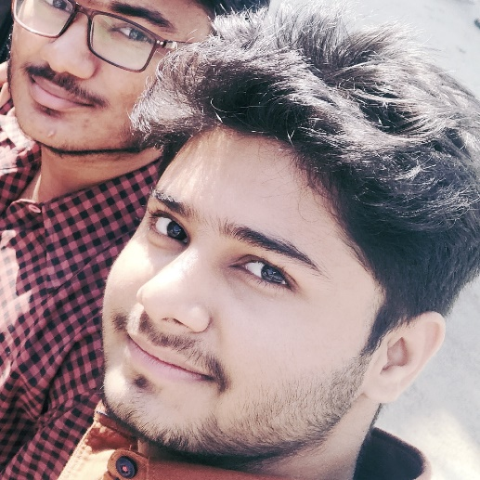 |  | AYUSH RASTOGI  B.TECH STUDENT
Profile  Github: https://github.com/ayu-lgtm  Hackerrank: Ayush Rastogi - 4225Ayush | HackerRank  Facebook:  Ayush Rastogi | Facebook  Contact  PHONE:  +91 8355068830  WEBSITE:  EMAIL:  Rastogi.ayush2000@gmail.com  Hobbies  Badminton  Cricket  Drawing  coding |  | EDUCATION  B.Tech. -Ajay Kumar Garg Engineering College,Ghaziabad  2019 -  J.KG.P.S.V.M.Inter College  2016 – 17 76%(intermediate) up board  2015- 16 94%(high school) up board  WORK EXPERIENCE  Fresher  SKILLS  - Python,  - java,  - c,  - html, css ,bootstrap,javascript  - IDLE used jupyter notebook,vs code,netbeens,eclipse

